**EXECUTIVE SUMMARY**

**Campaign Overview** - Our Daily Bread [www.ourdailybreadfrc.org], a food pantry which operates as a regional food bank for the city of Stillwater in Oklahoma. They operate as a Nonprofit organization. The goal of the proposed AdWords campaign was to profitably expand the reach of donation and fundraising initiatives of Our Daily Bread. Thus, resulting in an increase in donations and volunteer signups for Our Daily Bread. Through AdWords campaigns, our goal was to achieve an average CPC of $0.97, reaching between 5,000 to 8,000 impressions between 200to 350 clicks and an average CTR of 2.5% and higher, during the three-week campaign window.

**Key results -** After successfully building and running the campaigns for the span of three weeks, we managed to achieve an overall CTR of 3.62% and an average CPC of $0.95, for Google search network. A total of $249.55 of the budget was spent by the end of the campaign. The account accumulated 262 total clicks and 7,243 total impressions for google search network and 349 ad impressions for the google display network. The best performing Ad Groups were Food Donation which achieved an overall CTR of 6.20%, an average CPC of $1.02, and an Ad position of 1.3 and Volunteer Ad Group which realized an overall CTR of 4.61% an average CPC of $0.96 and an Ad position of 1.7. We believe our greatest AdWords achievement was the ability to develop a successful strategy that increased the CTR each week, while decreasing the average CPC.

**Conclusion** - Campaign success was attributed to a well-structured account that mirrored the structure of the Our Daily Bread website, frequent monitoring of performance metrics, use of Google tools (e.g., the Opportunities tab, Google Analytics, Traffic Estimator, AdWords Editor, and more), better geographical targeting for the ads and regular adjustment of keyword selection, matching options, and bidding strategy.  Ads for Our Daily Bread were served on the first search engine results page (SERP) with an Average Position (Avg. Pos.) between 1 and 3. New keywords with high search potential, as revealed by the Traffic Estimator, were continuously added to maximize clicks and the CTR.

**Future Online Marketing Recommendations** - The NGO can focus more preliminary towards a campaign of brand awareness and improve the content on their website making it easier for first time who are redirected from the ads to the user-friendly landing pages.

**Industry Component**

Our Daily Bread emphasized majorly on three key things, encouraging people to donate food, encouraging people to volunteer and lastly to promote their organization throughout USA. Following their requirements, we decided to build campaigns and target Google search and display network accordingly. After studying the overall website, we decided to create four campaigns. One campaign was designed to address food donation, one campaign was designed to address money donation, one campaign was designed to address volunteer sign up and one campaign was designed to address promotion of Our Daily Bread. All our campaigns are explained in much more details as follows.

**Campaign Overview**

**Campaign 1: Food Donation**

With this campaign, our main aim was to get people to the Our daily bread website. Doing so shall make people aware of what our daily bread does. We wanted to encourage people to donate more surplus food to Our Daily Bread. Details about the food donation drives is mentioned on the home page of the website. Strategically we wanted more people to click on the ads and come to the home page of the website. Hence, we kept the home page as our landing page for Food Donation campaign. The KPI that we were targeting here was click through rate. Our main aim with this campaign was to keep a high and steady click through rate. Following are the operational details for Food Donation campaign broken on a weekly basis.

Following is the overall performance dashboard for Food Donation Campaign

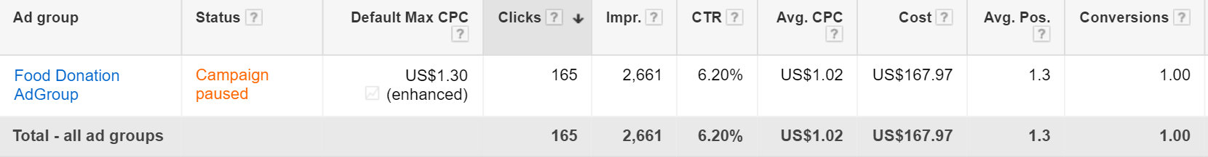Fig 1 – Food donation Ad group

In total, we invested $ 167.87 on the Food Donation campaign. It was the most successful campaign for us. It had a CTR of 6.20% and an average CPC of $ 1.02. Its average position was about 1.3. This campaign had one Ad Group called the Food Donation Ad Group. The Ad Group had three text ads in total

**Campaign 2: Money Donation Campaign**

With this campaign, our main aim was to make people donate money to Our Daily bread for their initiatives. Hence, we created a money donation campaign to encourage people to donate money to Our Daily Bread. Details about the Money donation drive is mentioned on the “Donate” page of the website. Strategically we wanted more people to click on our ads and land on our Donate page of the website. We could have tracked the conversion too with our campaign but since we did not have access to the HTML code of the website, we couldn’t implement the conversion tracking code on the Donate page. “Donate” page was our landing page for Money Donation campaign. The KPI that we were targeting here was click through rate. Our main aim with this campaign was to keep a high and steady click through rate. Following are the operational details for Money Donation campaign.

* Campaign Start date: 8th April 2017
* Campaign End date: 28th April 2017

Following is the overall performance dashboard for Food Donation Campaign

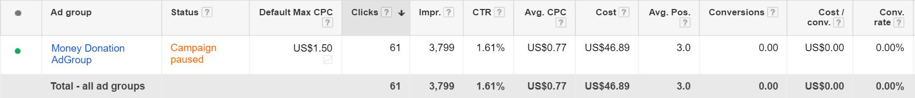

Fig 2 – Money donation Ad group

In total, we invested $ 46.89 on the Money Donation campaign. It had a CTR of 1.61% and an average CPC of $0.77. Its average position was about 3.0. This campaign had one Ad Group called the Money Donation Ad Group. The Ad Group had three text ads in total.

**Campaign 3: Volunteering Campaign**

With this campaign, our main aim was to make people sign up as a volunteer for Our Daily Bread. Hence we created a campaign for volunteering in order to encourage people to sign up as a volunteer with Our Daily Bread. Details about the volunteering activities is mentioned on the “Volunteer” page of the website. Strategically we wanted more people to click on our ads and land on our Volunteer page of the website. We could have tracked the conversion too with our campaign but since we did not have access to the HTML code of the website, we couldn’t implement the conversion tracking code on the Volunteer page. “Volunteer” page was our landing page for Volunteering campaign. The KPI that we were targeting here was click through rate. Our main aim with this campaign was to keep a high and steady click through rate. Following are the operational details for Volunteering campaign.

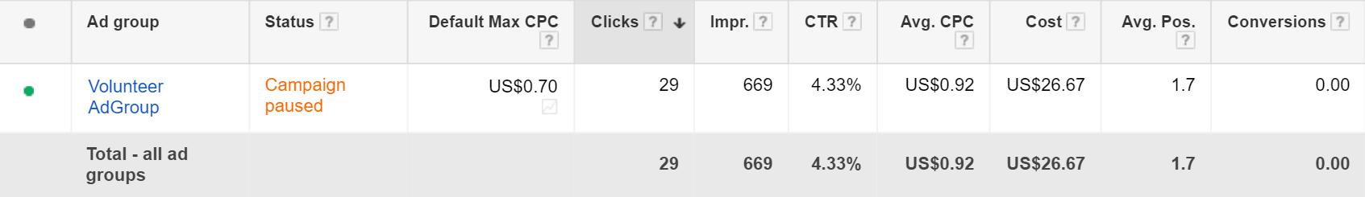Fig 3 – Volunteer Ad group

In total, we invested $ 26.67 on the Volunteering campaign. It had a CTR of 4.33% and an average CPC of $0.92. Its average position was about 1.7. This campaign had one Ad Group called the Volunteer Ad Group. The Ad Group had three text ads in total.

**Evolution of Campaign Strategy**

We started our campaigns at a preliminary level but we kept on trying different experiments on our campaigns. Post the first week, changes were done to our campaigns on regular intervals. Following are the changes that we did to our campaigns

* **Budget allocation**: We observed that Food Donation campaign was doing better than the rest,hence we allocated more budget to Food Donation Campaign Following graph shows the performance of campaigns on a weekly basis

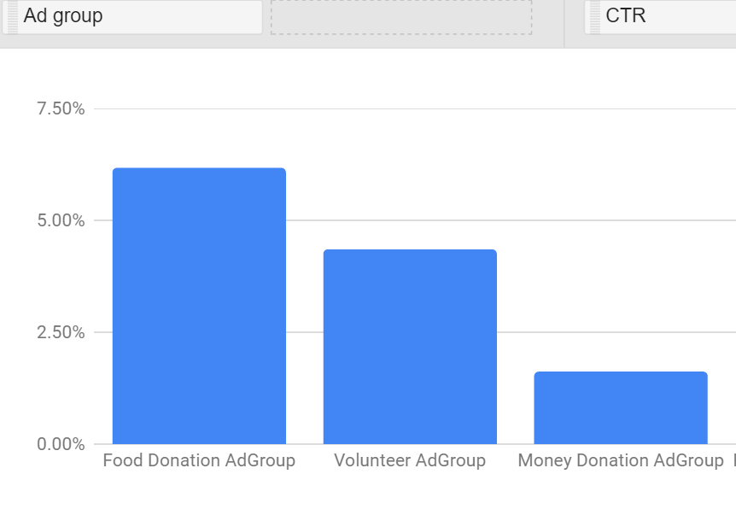

* **Use of Ad Extensions:** We made use of Sitelink and Call Ad extensions, which help improve ourquality score and ad rank. Collectively it helped us improve our CTR for the campaigns. Following are stats for the Ad Extensions.

**Fig 4 - Sitelink Extension**

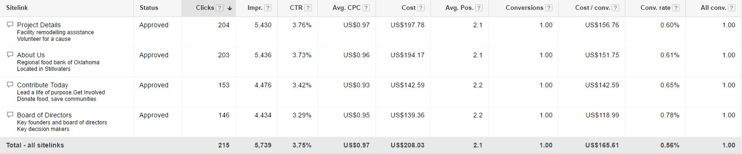

**Fig 5 - Call Extension**





* **Device Bid Adjustments:** We observed that we were getting more clicks from the mobile devicesthan the tablet or computer. Hence, we raised our bids for the mobile devices. Following is the device wise performance.

**Fig 6 – Device wise breakdown**

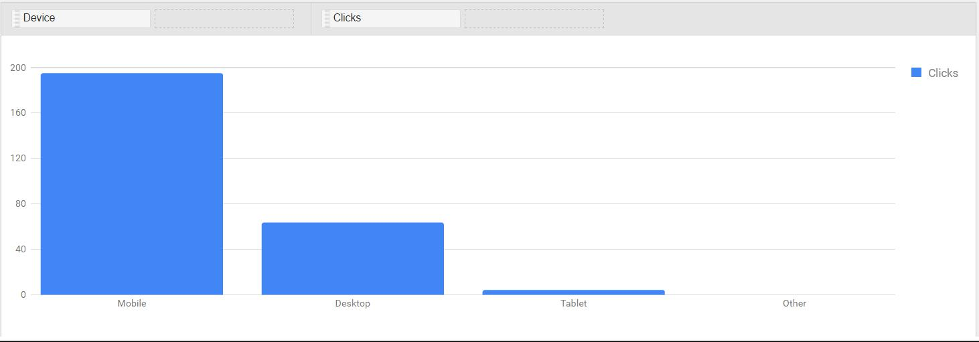

**Device level Statistics:** Following are the statistics for device level bid adjustments

**Fig 7 – Device level statistics**

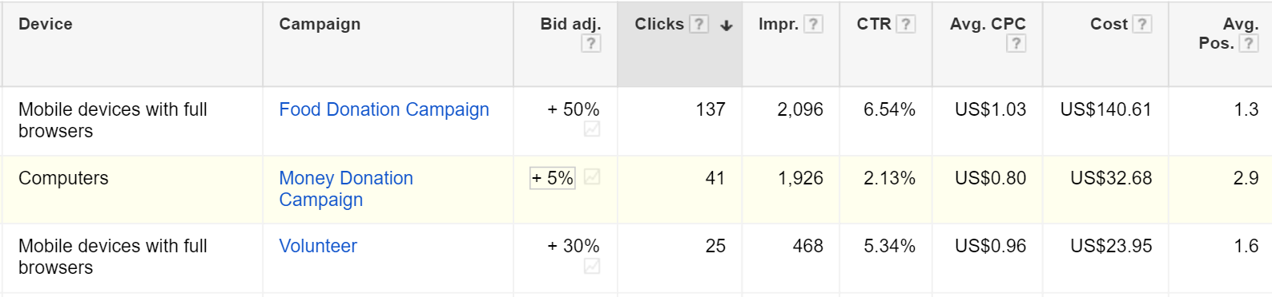

* **Running ads on prime time**: To optimize our campaign level performance, we ran our ads on prime time. We discovered that our ads were getting more clicks on the 8th, 9th and 10th hour of the day. Hence, we raised our campaign bids for above mentioned hours. Following is a performance graph with respect to hour of the day.

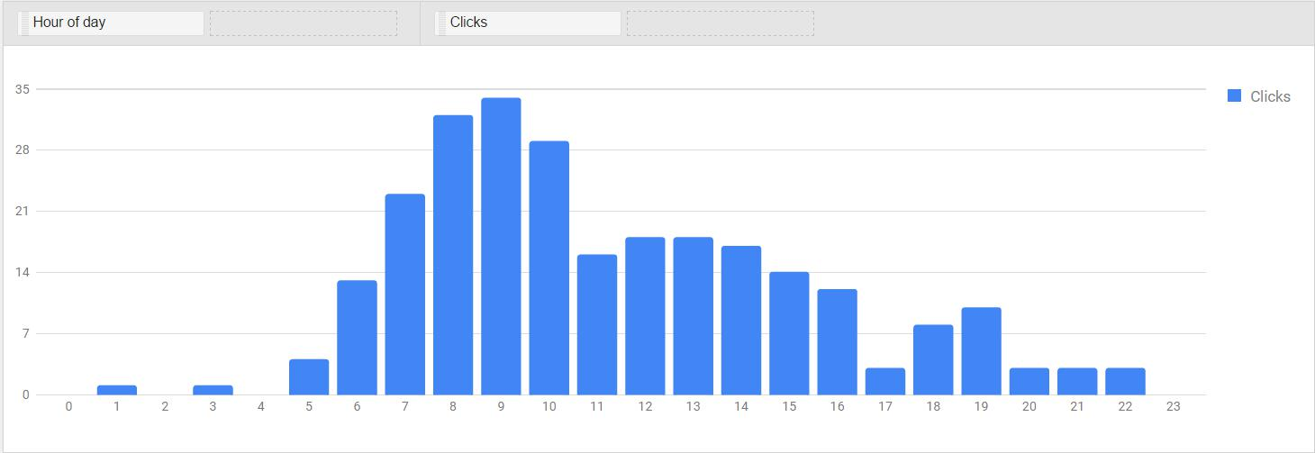

**Fig 8 – Time vs Clicks**

* **Keyword Refinements:** We experimented with keyword match types and used a mix of broad,exact and phrase match keywords. Throughout the span of the campaign we refined keywords on a weekly basis, better performing keywords were given more budget to perform and underperforming keywords were paused on a regular basis. Negative keywords were also added to the campaign to restrict irrelevant clicks

**Conclusions -** Our Daily Bread emphasized majorly on three key things, encouraging people to donate food, encouraging people to volunteer and lastly to promote their organization throughout USA. Following their requirements, we decided to build campaigns and target Google search and display network accordingly. After studying the overall website, we decided to create four campaigns. One campaign was designed to address food donation, one campaign was designed to address money donation, one campaign was designed to address volunteer sign up and one campaign was designed to address promotion of Our Daily Bread.

#### Future Recommendations - Google AdWords clearly helped our client generate more reach and volunteer enrollments. We recommend that our client increase the budget allocation for the Food Donation campaign and Volunteer Campaign. Because these two campaigns had a CTR of 6.20% and 4.33% respectively, as well as receiving the highest share of clicks, increasing the amount of the budget allocated to these areas should lead to an improved ROI, and increase the amount of unique visitors to the site. In order to increase ROI in the future we suggest creating new Ad Groups within each campaign.

**Learning component**

**Learning Objectives and Outcomes**

Working on the Google Online marketing challenge platform was a truly one of its kind learning experience where we got first-hand experiences of planning, implementing and analyzing the campaigns. We could learn most of the aspects of advertising through Google which included setting up the account structure, dividing our goals into various campaigns, allocating the budget across these campaigns and identifying the important KPI’s to track the success of these campaigns. We planned and setup the strategies to be executed to increase the charity’s brand awareness and at the same time help them with potential leads for volunteering as well as people who were interested in assisting them with Food donation as well as Money donation. With the Google AdWords platform, we targeted the audience based on the keywords they were looking for and tailoring our ads based on those keywords. Throughout the duration of the campaign, we analyzed the user behavior data through the reporting feature on Google AdWords and with this we could identify the trends which helped us further to improve the reach of the campaign and at getting more potential leads. The reporting data from AdWords helped us realize that our campaign achieved its maximum clicks on Saturdays and Sundays as compared to rest of the days of the week and the time slots between 8 am and 10 am were our most productive hours in terms of getting clicks towards the charity’s website.

**Group Dynamics**

Ours was a very focused group with a clear picture of the what are target goals were and the strategies we should be using to achieve these goals. Even though this was the first time, the four of us were working together, we had a solid understanding of what each other’s strengths and weaknesses which helped us perform effectively as a team. Each team member had their own areas of expertise in terms of planning, executing, marketing, presenting as well as analyzing the reports. Up front at the start of the campaign, we had a lot of different ideas and it was not possible to implement all of them due to the constraints of the budget, scope and time. Since we started the Google campaign before the Facebook campaign, we had to plan the campaign from scratch and we had a lot of constructive brainstorming sessions and after much deliberations we could narrow down on an approach to these campaigns and start steadily from that point onwards.

**Client Dynamics**

Our clients - Our Daily Bread located in Stillwater, Oklahoma were co-operative and helpful right from the start of the campaign. They were clear and concise about what expectations they had from this campaign and how they could assist us in getting the maximum conversions for the ads. The client got a tremendous response on the call extension feature that we had used while advertising about their NGO. We noticed, that it was very convenient for the locals from Stillwater Oklahoma to directly call the helpline number and inquire about how they could help the NGO in their objectives of feeding the needy by either providing food in the food pantries or by volunteering in food rives or help them build a warehouse that can house the substantial amounts of food that were donated to the NGO. The clients were skeptical about using the Analytics code on their website or providing us access to the NGO’s website’s source code and hence we were not able to merge our GOMC AdWords account with the Google analytics account which would have provided us with even better insights about the user behaviors

**Future recommendations**

With regards to the clients, the suggestions that we would like to provide are that ‘Our daily bread’ website has been hosted on Wix.com and a basic template has been used for the same. The flow of information is a bit confusing for the first-time users and there is no implementation of SEO techniques on the website which could help improve the organic search listings for the website and improve the quality scores for the ads devised for their platform. There is a ‘donate now’ option on each of their page, we believe that if the information on their website was divided better categorically, it would have been easier for the audience to get better idea of which page they were on and ultimately lead to more potential conversions. The things we would have done differently would be spending more cautiously in the initial weeks to identify our best performing keywords, target audience and ads and tailor our campaigns based on the various KPI’s that we used to track the success of our campaigns. We could have adopted a more dynamic approach to start with so that we could have tailored our campaigns as per the data we analyzed through the reporting feature of AdWords